6.90: a) The hummingbird produces energy at a rate of 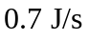to 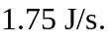 At 10 beats/s, the bird must expend between 0.07 J/beat and 0.175 J/beat.
b) The steady output of the athlete is 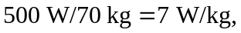which is below the 10 W/kg necessary to stay aloft. Though the athlete can expend 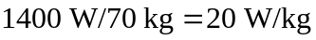 for short periods of time, no human-powered aircraft could stay aloft for very long. Movies of early attempts at human-powered flight bear out this observation.

